
CYBERSTER
NetSec Internship - Week 4 Task Report

Intern Name: | Muhammad Raza
Instructor Name: | Muhammad Huzaifa Riaz
Company: | CYBERSTER (Batch 2)
Task: | Three-Tier Hierarchical Network Design
Date: | 18 July 2026

Table of Contents

Section
1. Network Topology Upgrade: Week 3 → Week 4 | 3
1.1 Week 3 Baseline Topology | 3
1.2 Week 4 Three-Tier Topology | 3
1.3 Upgrade Summary | 4
2. Three-Tier Architecture Overview | 4
3. Device Justification by Layer | 5
3.1 Core Layer - The Backbone | 5
3.2 Distribution Layer - The Policy Boundary | 5
3.3 Access Layer - The Edge | 6
4. Architectural Comparison: Access vs. Distribution Layer | 6
5. Conclusion | 7

1. Network Topology Upgrade: Week 3 → Week 4
To ensure scalability, fault isolation, and efficient traffic management, the foundational Layer 2 and ROAS topology developed in Week 3 was upgraded into a standard enterprise Three-Tier Hierarchical Model. New dedicated hardware was introduced, including centralised servers, a Distribution switch, and wireless infrastructure, and the network boundaries were visually redefined into distinct Core, Distribution, and Access layers as per industry best practices.

1.1 Week 3 Baseline Topology
The Week 3 network consisted of a flat two-tier model: a single Core Switch aggregating two Access Switches, with a 1941 Router performing inter-VLAN routing via the Router-on-a-Stick technique. While functional, this design lacked a dedicated policy/aggregation layer and offered no separation between server infrastructure and end-user traffic.

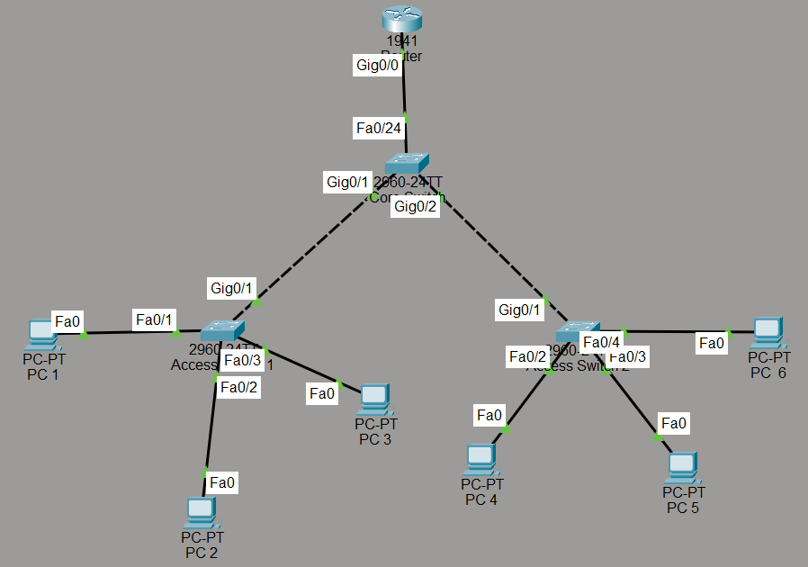
Figure 1: Week 3 baseline - two-tier ROAS topology with Core Switch, two Access Switches, and 6 end-user PCs.

1.2 Week 4 Three-Tier Topology
The Week 4 upgrade introduces a fully segmented three-tier hierarchy. A dedicated Core Layer houses centralised servers and the backbone switch. A new Distribution Layer hosts the router, an aggregation switch, and a Cloud/WAN emulation. The existing Access Layer is retained with two Access Switches, expanded with a wireless Access Point and a Laptop for wireless endpoint coverage.

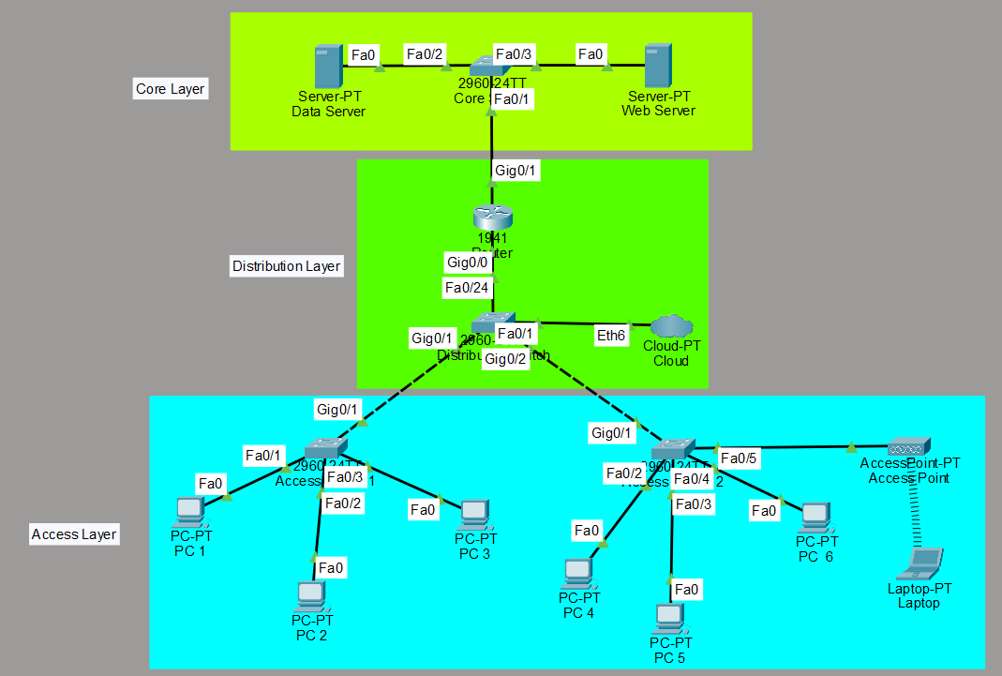
Figure 2: Week 4 upgraded topology - Three-Tier Hierarchical Model with Core, Distribution, and Access layers clearly delineated.

1.3 Upgrade Summary
The following table captures the key changes introduced between the two topology versions:
Component | Week 3 (Baseline) | Week 4 (Upgraded)
Architecture | Two-Tier (Core + Access) | Three-Tier (Core + Distribution + Access)
Routing | ROAS on Core Switch uplink | Dedicated 1941 Router at Distribution Layer
Servers | None | Data Server + Web Server at Core Layer
Switching | 1 Core Switch + 2 Access Switches | Core Switch + Distribution Switch + 2 Access Switches
Wireless | None | Wireless Access Point + Laptop at Access Layer
WAN/Cloud | None | Cloud-PT emulation at Distribution Layer
End Devices | 6 PCs (wired only) | 6 PCs + 1 Laptop (wired + wireless)
Segmentation | VLAN-based, flat boundary | Physical + logical layer boundaries enforced

2. Three-Tier Architecture Overview
The Cisco Three-Tier Hierarchical Model is the gold standard for enterprise network design. It separates network functions into three distinct tiers — each with a clearly defined role — enabling independent scaling, fault containment, and simplified troubleshooting.

Tier | Primary Role | OSI Layer | Devices in This Lab
Core Layer | High-speed backbone; fast transport of data between Distribution and server infrastructure | Layer 2 (switching only - no policy) | Core Switch (2960), Data Server, Web Server
Distribution Layer | Policy enforcement, inter-VLAN routing, traffic aggregation, WAN/Cloud gateway | Layer 3 (routing + policy) | 1941 Router, Distribution Switch (2960), Cloud-PT
Access Layer | End-user connectivity; port-level security; wired and wireless endpoint access | Layer 2 (switching + port security) | Access Switch 1 & 2 (2960), Access Point, PCs, Laptop

3. Device Justification by Layer
Each device was strategically placed within the hierarchy to fulfil the unique performance, security, and functional requirements of its tier. The following sub-sections detail the rationale behind every placement decision.

3.1 Core Layer - The Backbone
CORE LAYER - Primary Function: High-Speed Backbone & Server Farm
Device | Role | Why Placed Here
Cisco 2960 Core Switch | Backbone switching - connects servers to Distribution Layer via Gig0/1 trunk | Provides wire-speed Layer 2 forwarding for server traffic. Dedicated core switch ensures server-bound traffic never competes with edge congestion.
Data Server | Centralized storage for organizational file shares, databases, and internal resources | Core placement guarantees all internal hosts reach critical data via the high-speed backbone, not through slower edge links.
Web Server | Hosts internal and external-facing web applications and services | Centralising the web server at the core enables the Distribution Layer to apply ACLs and security policies to all inbound web traffic before it reaches the server.

3.2 Distribution Layer - The Policy Boundary
DISTRIBUTION LAYER - Primary Function: Routing, Policy Enforcement & WAN Gateway
Device | Role | Why Placed Here
Cisco 1941 Router | Inter-VLAN routing, ACL enforcement, and WAN/Cloud gateway | This layer requires Layer 3 intelligence. The router is the only device capable of routing between VLANs and connecting to external networks (Cloud/WAN). Centralising this here keeps routing logic entirely out of the Access Layer.
Distribution Switch (2960) | Aggregates uplinks from all Access Switches and passes them to the Router | Acts as the aggregation point, consolidating multiple Access Switch trunk links into a single high-capacity uplink to the router. This prevents the router from needing individual ports for every access switch.
Cloud-PT (WAN Emulation) | Simulates an external WAN/Internet/Cloud connection at the network boundary | The Distribution Layer is the defined boundary between the trusted internal network and untrusted external environments. Connecting the Cloud here correctly models real enterprise WAN termination and VPN endpoints.

3.3 Access Layer - The Edge
ACCESS LAYER - Primary Function: End-User Connectivity & Edge Security
Device | Role | Why Placed Here
Cisco 2960 Access Switch 1 & 2 | Provides wired port connectivity for end-user PCs (PC 1-6); enforces VLAN segmentation and port security at the edge | Layer 2 switches are the most cost-effective way to provide high-density port connectivity. This is the only layer where end devices physically plug in. VLAN and port security must be enforced here, closest to the endpoint.
Wireless Access Point (AP) | Provides 2.4 GHz wireless connectivity for the Laptop endpoint | APs are edge devices - their sole function is extending network access wirelessly to end-user devices. They operate at Layer 1/2 and have no routing intelligence, making them exclusively an Access Layer device.
PCs (PC 1-6) & Laptop | End-user hosts; consumers of network resources | End devices are always Access Layer entities. They connect directly to switches or APs and have no knowledge of, or interaction with, the Distribution or Core layers.

4. Architectural Comparison: Access vs. Distribution Layer
While both layers are critical to network functionality, the primary difference between the Access Layer and the Distribution Layer lies in their operational scope, OSI layer of operation, and intelligence within the traffic flow. This is a key architectural concept required by the Week 4 task brief.

Criterion | Access Layer | Distribution Layer
Primary Purpose | Provide end-user/device connectivity to the network | Aggregate access traffic; enforce routing and policy
OSI Layer | Layer 2 (Data Link — switching only) | Layer 3 (Network — routing + policy)
Connects To | End devices: PCs, Laptops, Printers, IP Phones, APs | Access Switches below; Core Switch/Router above
Routing | No routing — forwards frames using MAC addresses only | Full inter-VLAN routing; connects to WAN/Cloud
Security Functions | Port Security, VLAN Assignment, 802.1X authentication | ACLs, Firewall rules, QoS policies, VPN termination
Traffic Type | User-generated endpoint traffic (mostly east-west at edge) | Aggregated, policy-filtered traffic (north-south flow)
Devices | Cisco 2960 Switches, Access Points, End Hosts | Cisco 1941 Router, Distribution Switch, Cloud/WAN
Scalability Impact | Adding more ports/switches here does not affect routing | Changes here affect all downstream access switches simultaneously
Failure Blast Radius | A failure affects only the directly connected end devices | A failure can disrupt entire VLAN segments or WAN access

5. Conclusion
This Week 4 task successfully demonstrated the design and justification of a complete enterprise Three-Tier Hierarchical Network using Cisco Packet Tracer. By evolving the Week 3 two-tier model into a fully segmented three-tier architecture, the following objectives were achieved:

✓ | Objective
✓ | Topology correctly segmented into Core, Distribution, and Access layers with visually defined boundaries.
✓ | Each device placement is justified by its functional role and the capabilities required at that tier.
✓ | Servers (Data + Web) are centralised at the Core Layer, ensuring they are accessible at backbone speed and protected by Distribution-layer policies.
✓ | The Distribution Layer correctly handles inter-VLAN routing, traffic aggregation, and simulated WAN/Cloud connectivity via Cloud-PT.
✓ | The Access Layer provides high-density wired and wireless endpoint connectivity while applying port-level security at the network edge.
✓ | The architectural distinction between the Access and Distribution layers has been thoroughly documented - covering OSI layer, purpose, security scope, and failure impact.

The Three-Tier Hierarchical Model is not merely an academic exercise - it is the foundational blueprint used in production enterprise networks worldwide. Each tier’s separation of concerns ensures that the network can scale independently, failures remain contained, and security policies can be applied precisely at the correct boundary, from the backbone server farm all the way down to the end-user’s desk.

